THE NIGERIA TELECOMMUNICATIONS GIANTS AND THEIR SOCIAL MEDIA HEALTH

DEREK OSAWAGUAN AHAMIOJE

Table of Contents

INTRODUCTION 3

1.0 PREAMBLE 3

1.1 TELECOMMUNICATION IN NIGERIA 3

1.2 BUSINESS ANALYTICS 4

1.3 AIMS AND OBJECTIVES 5

2.1 DATA 6

2.2 ANALYSIS AND VISUALISATION 6

2.3 DATA HARVESTING 6

2.3.1 TWITTER 7

2.3.2 TWINT API 7

2.4 DATA ANALYSIS AND VISUALIZATION 8

2.4.1 Tableau 8

2.4.2 Python 8

RESULTS AND DISCUSSIONS 10

CONCLUSIONS, PROJECT LIMITATIONS, AND RECOMMENDATIONS 25

4.1 Conclusion 25

4.2 LIMITATIONS 25

RECOMMENDATIONS 25

REFERENCES 26

# **Abstract**

**Purpose:** There is a strong correlation between the perception of customers toward a business service and the level of patronage towards the business. In a situation where there is a positive perception, the tendency to subscribe to the service will be high. Most businesses have deployed social media as a medium for selling their products and obtaining feedback from both their customers and prospective customers. Therefore, this study uses the social media analysis of four major telecommunications providers in Nigeria (MTN Nigeria, Globacom, Airtel, and 9mobile) to extract useful sentiments.

**Design:** 5000 tweets from the Twitter handle of each of the service provider was scraped and visualized using Tableau, a visualisation tool, and python visualization with latent Dirichlet allocation technique.

**Findings:** It was observed that responses from customers and potential customers were higher when providers made offers. Providers like MTN with larger followers enjoyed pleasurable sentiments when compared with others like 9moblie and Airtel with very low followership, which had dissatisfactory sentiments.

**Business Implications:** The implications for these service providers are that this analysis presents before them, the unscrutinized, uncontrolled, and cheap feedback system for identifying key areas of customer satisfaction.

# **INTRODUCTION**

## 1.0 **PREAMBLE**

This research is aimed at gaining a deeper understanding of the perception of telecommunications subscribers in Nigeria towards their chosen telecommunications service providers. It contains background on the telecommunication industry in Nigeria, the major service providers and the objectives of this study, design method, analysis, results evaluation, and conclusion from the study.

## 1.1 **TELECOMMUNICATION** **IN NIGERIA**

The Telecommunications industry in Nigeria has over the decades experienced a huge increase in the number of subscribers across the six geopolitical zones of the country. This advancement no doubt has contributed in no small way to improving the quality of life of these subscribers, from increasing communication links among families to enhancing customer reach (CR) for businesses and translating to an increase in business profit. However, in Tekanyi *et al*., 2019 while it was acknowledged that the Global System for Mobile (GSM)

communications technology has become one of the fastest growing technologies, it also affirms that the telecommunications technology is one of the most challenging technologies. These challenges were assessed for efficiency in terms of the quality of services delivered on the basis of The Call Setup Failure Rate (CSFR) and Hand-Over Failure Rate (HOFR). From the business perspective of the Telecommunication industries, a key predictive indicator for their profit will depend largely upon the level of satisfaction that their customers enjoy for subscribing to the services offered to them. However, according to Tekanyi *et al., 2019,* maximum customer satisfaction has not been the case over the years resulting from the increase in Hand-over Failure Rate and poor network availabilities due to an increased Call Setup Failure Rate which has become a great source of concern to providers, users, and researchers.

Ononiwu *et al*., 2016 while reviewing four major GSM providers in Nigeria (Globacom, Airtel, 9mobile, and MTN) opined that by continuously tracking, evaluating, and enhancing the radio network performance (RNP) to deliver higher subscriber quality, Mobile Network Operators (MNO) may dramatically increase their profitability growth rates and financial stability. The research feedback conducted in the south-east part of the country using the RNP indicator showed that these network providers failed to comply with the Stipulated Performance Threshold (SPT) as recommended by the Nigerian Communications Commission (NCC), a regulating body for communication Networks in Nigeria.

Abayomi (2011), had conducted similar research in the southwestern part of Nigeria by performing T-test, F-test, [at 95% confidence limit], Cross-tabulation [using the ‘Eta’ Directional measure], and statistical charts on a set of data extracted from a user survey conducted in the region. This was done to assess subscribers’ satisfaction with their chosen GSM service providers.

According to Folorunsho and Nkemdilim (2020), the GSM market in Nigeria is one of the fastest growing in the world and contributes around 10% of the country's GDP. According to Oghojafor *et al*., (2014), the sector has fallen behind the other industries in terms of consumer satisfaction and loyalty. Sanusi and Oloyede, (2014) while analysing the telecommunications sector in Nigeria, had identified the biggest players in the industry otherwise code-named “the big four” as - MTN Nigeria, Glo Mobile (Globacom), 9Mobile, and Airtel Nigeria. The performance evaluation by the Nigerian Communications Commission (NCC) in terms of market shares is shown in Figure 1, where MTN Nigeria ranked highest in market shares with an aggregate of 38% even though it was a record drop from 39.61 percent of the market share the previous year (Folorunsho and Nkemdillim, 2020). Glo and Airtel at equal shares of 28%. While 9mobile had a 9% market share.

However, beyond these measures used in assessing the service providers, recent development has seen the use of machine learning algorithm to extract the true intent of a writer about a specific subject through their uncontrolled written text, which is otherwise described as sentiment analysis; subjectivity analysis, opinion mining and appraisal extraction (Mejova, 2009). This can better give an insight into the following analytical question;

1. Are the subscribers in Nigeria satisfied with their network providers?
2. What are they saying about the services they receive?

## 1.2 **BUSINESS ANALYTICS**

Gaining new insights into business is important for a business desiring to improve its performance in several ways such as; quality service delivery, growing the business profit margin, identifying new markets or potential markets, minimizing loss, etc. Therefore, as organizations are working hard to have a competitive advantage over their competitors, business analytics has become increasingly important in achieving the competitive advantage (Mikalef *et al*., 2019), to several studies have underscored the positive implications business analytics has had on business output (Ashrafi *et al.*, 2019)).

## 1.3 **AIMS AND OBJECTIVES**

This study aims to extract meaningful sentimental feedback from the service subscribers through the social media handles of the respective network providers and use such feedback to propose solutions to areas of improvement for the service provider. To execute this aim, the following objectives have been put in place;

1. Identify the effective Twitter handle for Nigeria’s top four telecoms provider.
2. Extract relevant data including feedback from the social media hand using a suitable API
3. Visualise the extracted data using Tableau and Python
4. Identify areas of improvement for each network provider for an enhanced customer base

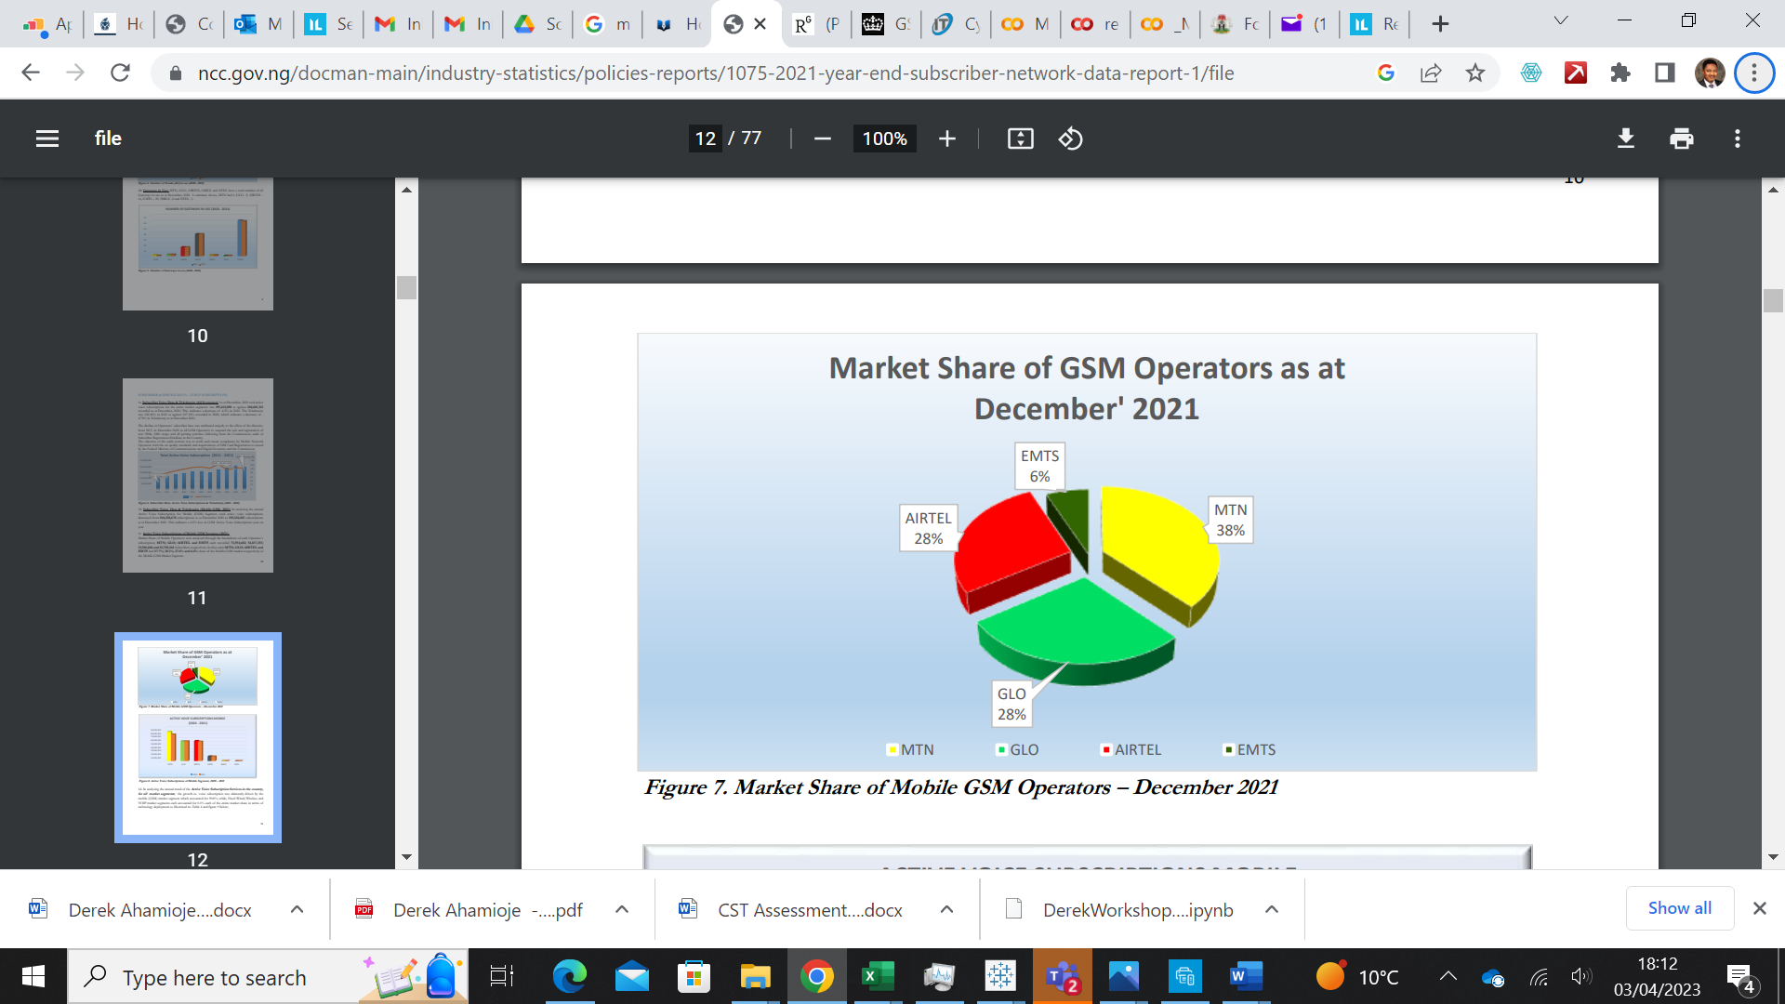

Figure 1: Market Share of Mobile GSM Operators in Nigeria – December 2021 (NCC. 2022)**RESEARCH DESIGN**

The research work was done using the following grouping: Data and Analysis.

## 2.1 **DATA**

The aim of the study is to analyse the social media feeds of the selected telecoms providers in Nigeria, therefore in the task of obtaining the dataset, the choice of social media handle that will best provide these data was drawn from some important characteristics' questions, such as:

1. How many social media handles are these telecoms operating?
2. How active are they in the media?
3. Which medium provides sufficient data for this analysis?

The data under investigation are both historical datasets and real-time. The Historical dataset is the obtained data covering the dates preceding the date the data was harvested, while the real-time data were the data harvested at the exact time it was posted on the page. The two focuses in terms of the type of data in this study are textual data and numerical data and combining both to make a useful conclusion.

## 2.2 **ANALYSIS AND VISUALISATION**

The next phase of the study is to carry out some analysis of the data obtained. This is the data analytics stage, which is the process of examining the data to observe possible trends and therefore make informed conclusions from the observations.

2.3 **DATA HARVESTING**

According to Batrinca, and Treleaven, (2015), Social media data is often either accessible through a simple and straightforward general method or may require the researcher to programme their analytics in a language like MATLAB, Java, or Python. The dataset used for the analysis of the social media feeds of the chosen telecommunications companies (MTN Nigeria, Globacom Nigeria, Airtel Nigeria, and 9mobile Nigeria), was obtained from Twitter by a technique known as scraping and using the Python language.

### 2.3.1 TWITTER

Twitter a foremost social media provider was the source of the data used in the study. Unlike some providers with unrestricted access to data, Twitter allows only restricted access to data in its platform, therefore, denying access to the whole data. It, however, grants limited access right for research purposes through its approved API (application programming interface), which must be obtained through the predefined process of application and approval for a developer account. In this study, the effort to secure a developer account was difficult based on the fact that the approval was being delayed while the timeline for the study was running out. However, twint was identified as an API that can scrape data.

### 2.3.2 TWINT API

Twint is an advanced tool for data scraping without the need for Twitter API, and it is written in Python programming language. Twint is an awesome API when it comes to obtaining tweets, but it also has its limitations when it comes to interacting with Twitter (such as making a post or sending direct messages). In this study, our focus is obtaining tweets therefore, twint is just sufficient for use. Figure 1 shows the features of the data scraped using twint.

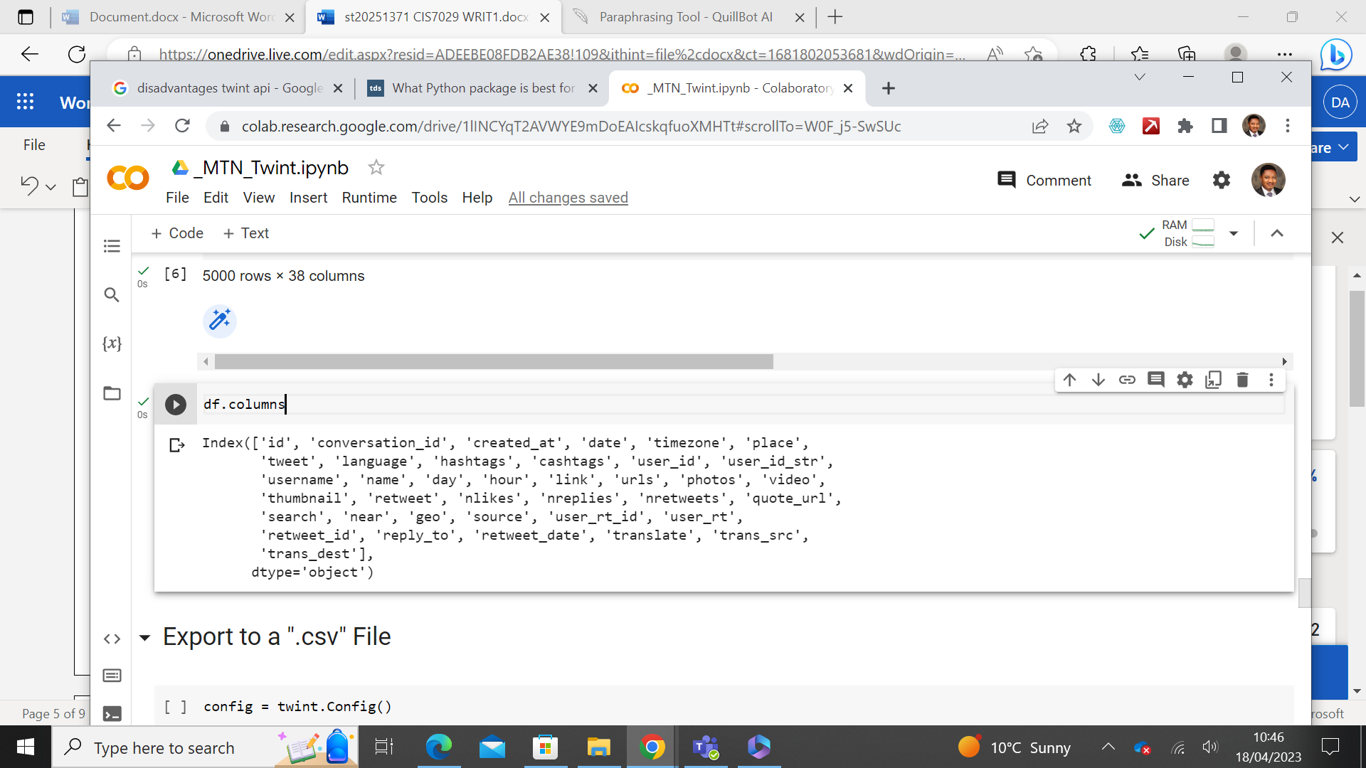

Figure 2: Features of data obtained from Twitter using twint API

For an effective analysis, a total of five thousand (5,000) tweets were scraped with 38 features each as shown in Figure 2 above, for MTN, Globacom, 9mobile, and Airtel respectively using python language. The key features that address the aim were identified for analysis and visualisation

## 2.4 **DATA ANALYSIS AND VISUALIZATION**

The data scraped from the Twitter handle of the four telecommunication providers in Nigeria were subjected to a standard algorithm of analysis and visualisation using a combination of two visualisation tools; Tableau and Python.

### 2.4.1 Tableau

Tableau, a data visualisation tool was used for the pictorial and visual representation of the data to observe the interactions between chosen features in this analysis. The choice of Tableau for visualisation was made because of its simplicity, ease of use for new users including those with minimum experience, and the amazing visualisation it can generate. Tableau was used on the numeric data to analyse interactions between the providers and their subscribers, using features such as; the number of likes, number of replies, and number of retweets.

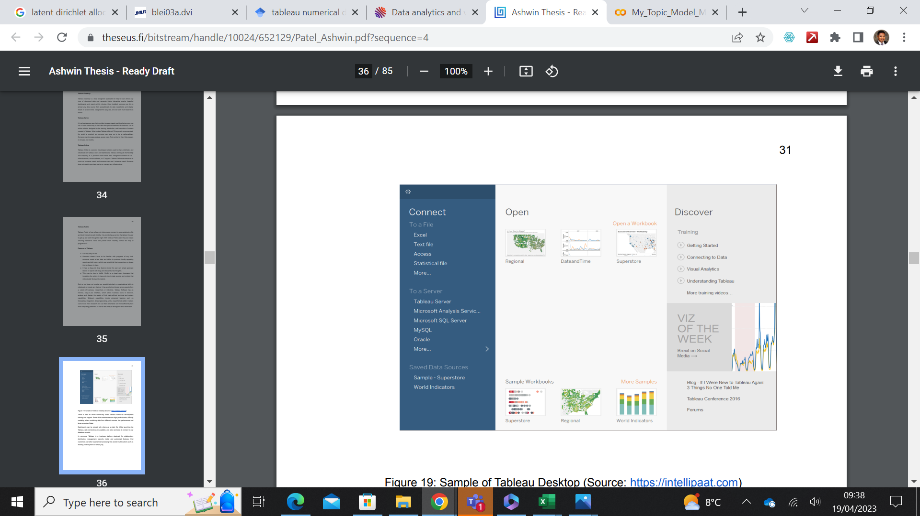

Figure 3: Sample display of Tableau desktop (Source: Patel, 2021)

### 2.4.2 **Python**

Python language, a fifth-generation programming language was used to build the Latent Dirichlet Allocation (LDA) model; a generative probabilistic model for collections of discrete data such as text corpora (Blei, *et al*., 2003). The model was used to create visualisations based on topic relevance using the gensim python library thereby presenting subscribers’ opinions in a visual form.

The choice of using python for this purpose was because it is a familiar tool for textual data analysis, and its use by researchers in analysing tweets from Twitter (Negara, *et al*., 2019).

# RESULTS AND DISCUSSIONS

Results obtained from the study show that a total of 5000 tweets were scraped with twint API for GloWorld, 9mobile, and Airtel while for MTN, 5001 tweets were scraped using the same size limits of 5000. The tweets scraped covered different periods, based on the number of tweets from each handle. MTN Nigeria had the tweet spread from the 15th of January, 2019 to the 31st of March, 2023, and Globacom had its entire number of tweets from the 24th of February 2023 to the 31st of March 2023. However, 9mobile and Airtel tweets spread from the 20th of February, 2023 to the 31st of March and the 25th of March to the 31st of March, 2023 respectively. Figure 4 shows the tweet count for each network provider. Preliminary assessment shows that the average tweets per day from each network provider based on the total number of tweets scraped and the time stamp for each tweet indicates that MTN Nigeria, 9mobile, Globacom, and Airtel, had average tweets per day of 4, 125,139 and 714 tweets per day, which already, raises interest as to how well will each provider perform based on the volume of their tweets and also we can draw further inference from the content of the tweets based on the statistics shown in Table 1, where despite having 4 tweets per day, MTN Nigeria attracted a total of 334,161 likes and 120,512 replies, while Airtel with the highest number of tweets per day recorded 236 likes and 190 replies in all.

Table 1: Preliminary results from scraped tweets for all networks

|  |  |  |  |  |  |
| --- | --- | --- | --- | --- | --- |
|  | **No. of tweets** | **No. of days** | **Average tweets per day** | **Total No. of Likes** | **Total No. of Replies** |
| MTN Nigeria | 5001 | 1171 | 4 | 334,161 | 120,512 |
| GloWorld | 5000 | 36 | 139 | 4,795 | 3247 |
| 9mobile | 5000 | 40 | 125 |  |  |
| Airtel | 5000 | 7 | 714 | 236 | 1903 |

Figure 4: Tweet count for each network provider

Results obtained with the Tableau visualisation tool highlighted tweets in the order of the sizes of the number of likes per tweet and number of replies per tweet, which suggests that tweets with more likes are satisfactory to the customers more than those with fewer likes, while those with more replies are more interactive than those with fewer replies. On this basis, Figure 5, is a dashboard view showing the growth of the likes per tweet that each provider attracted and the respective dates each provider attracted the highest and lowers numbers of likes. MTN Nigeria had the top three highest likes for tweets made in February 2022, November 2021, and January 2023 with 33,387, 29,450, and 19,315 likes respectively. Globacom had 1,099, 506, and 475 likes on 8th March 2023, 26th February 2023, and 17th March 2023 respectively. 9Mobile also had 64, 63, 62 likes on February 28th, March 24th, 2023, and March 22nd, 2023 respectively.

Figure 5: Growth of the number of likes per tweet for network providers

However, a comparison of the number of likes with the number of replies shows that tweets with the highest number of likes may not necessarily translate to having the highest number of replies as shown in Figure 6. In the case of Globacom, while the number of tweets with the highest likes is tweets of 8th March 2023, 26th February 2023, and 17th March 2023, those with the highest replies are March 12th, March 28h, and March 15th. The same applies to Airtel, on one occasion with MTN. Observations with 9mobile were different because the number of replies was observed to be higher than the number of likes and in those cases, the number of likes was high where the number of replies was also high.

Figure 6: Dashboard showing a compare between the number of likes and with number of replies

Furthermore, a look at the first three highest likes and first three highest replies shows that for MTN as shown in Figures 7a, b, and c, The tweet with the highest likes of 29,038 and 6547 replies was a tweet announcing a comeback in 2022 which suggests the excitement of subscribers with the return. While the second highest (figure 7b) was a message of inspiration at the beginning of the year, it attracted 10,827 likes and 640 replies and the third was an advert presented in the form of self-identity, which can also be perceived as a motivation. (Figure 7c)

Figure 7a: MTN tweet with the highest number of likes

Figure 7b: MTN tweet with the second-highest number of likes

Figure 7c: MTN tweet with the third-highest number of likes

The top three highest number of likes for Globacom is shown in Figures 8a, 8b, and 8c respectively. The tweet with the highest likes was offering discounts and it attracted a total of 630 likes and 33 replies (figure 8a), the tweet with the second highest also offered discounts (figure 8b), while the third highest likes addresses women empowerment on international women’s day(Figure 8c)

Figure 8a: Globacom tweet with the highest number of likes

Figure 8b: Globacom tweet with the second-highest number of likes

Figure 8c: Globacom tweet with the third highest number of likes.

The feedback from 9mobile Nigeria reveals that the tweets with the first two highest likes were apologies. While the highest (figure 9a) was apologizing for barring a subscriber’s line, the second was apologising for the inability to provide the subscribers’ requested information. However, just like Globacom, the third highest was also eulogizing women on international women’s Day.

Figure 9a: 9Moblie tweet with the highest number of likes

Figure 9b: 9Mobile tweet with the second highest number of tweets

Figure 9c: 9Mobile tweet with the third highest number of likes

However, in the case of Airtel, the number of likes and replies per tweet was very low with the highest out of a total of 5000 tweets being 6 suggesting that Airtel’s presence on Twitter is very low and insufficient for its assessment. Appendices 1, 2, and 3 are visuals of these statistics.

Sentiments analysis on the replies to tweets reveals that for MTN, the first three tweets with the highest number of replies had an engaging approach to the tweets. While the tweet with the highest replies presented a reward for people who will post their phone numbers and tag their friends. See Figure 10. The same approach was used for subscribers in the second and the third highest as shown in Figures 10b and 10c respectively. Another notable observation from these tweets shows that the number of replies was more than the number of likes, indicating that people were more interested in the reward than in indicating their likeness.

It was different for GloWorld and 9mobile where their tweets were in the form of posing fun game questions, which also, attracted more replies than likes in each post, but in much smaller counts respectively when compared with the total counts from MTN.

Figure 10a: MTN tweet with the highest number of replies

Figure 10b: MTN tweets with 2nd highest number of replies

Figure 10c: MTN tweet with 3rd highest number of replies.

The topic modeling analysis performed with python language identified keywords in the collection of tweets and using a machine learning algorithm classified keywords into relevant topics based on semantic similarity. Figures 11a, 11b, 11c, and 12a, 12, 12c, shows the estimated term frequency of keywords in the first three topics in MTN, and Globacom.

Figure 11a: Terms relevance for MTN topic 1

Figure 11b: Terms relevance for MTN topic 2

Figure 11c: Terms relevance for MTN topic 3

Figure 12a: Relevant terms for GloWorld Topic 1

Figure 12b: Relevant terms for GloWorld Topic 2

Figure 12c: Relevant terms for Globacom Topic 3

A word cloud obtained from these selected topics also agrees with the result obtained from the bubble plot in Tableau where the first three tweets with the highest replies share the same keywords as the first three topics in the word cloud as shown in Figure 13 for instance, where the word cloud is screaming “mtn #socialmediaspree”, “Https”, “tco” etc. On the other hand, Figure 14 shows the word cloud for Globacom screaming more of “issue”, “sorry” , “assistance”, apologies, etc., which suggests that the subscribers had a lot of issues using the network within the period under review.

Figure 13: word cloud for MTN’s first four topics

Figure 14: GloWorld word cloud for the first four dominant topics

# **CONCLUSIONS, PROJECT LIMITATIONS, AND RECOMMENDATIONS**

## 4.1 Conclusion

Guided by the objective of this study, Twitter was identified as a social media platform where suitable data can be extracted for the different telecom organisations. The use of twint API, an open-source API, was able to scrape sufficient data (5000 tweets in less than a minute) from Twitter without using the regulated Twitter API.

The result obtained from this study and, based on the analysis conducted on the scraped data with python and Tableau, it can be concluded, that of the four network service providers, MTN Nigeria stands out as the most attractive and satisfactory service provider to its subscribers whom they have, regularly involved in their subject of the day, through their juicy, on-the-go freebies and other offers on their Twitter handle. The study further has shown that the quality of tweets is way more important than the number of tweets, as seen in the case of MTN has an average tweet of 4 per day and yet can attract a total of 334,161 likes and 120,512 replies, while the likes of Airtel tweeted 5000 tweets in 7 days and yet could only attract a total of 234 likes or 1903 replies.

Furthermore, to optimize traffic to the media hand, telecom providers that are posing brain teaser questions have advantages over those that are not using either brain teaser questions or offering freebies.

## 4.2 LIMITATIONS

This study, however, experienced some limitations. The major limitation was;

1. Delays in securing a Twitter developer account. The implication of this is that the data scraped with twint, did not display some features like geographical locations which would have helped in identifying location-based sentiments.

## RECOMMENDATIONS

The study has however established among others that the quality of tweets can attract huge traffic to the providers’ page, thereby creating room for increased daily advertisement of their products and services but did not provide answers to how it has contributed to the company’s financial status and hence would recommend this aspect for further study.

# REFERENCES

Abayomi, A.S., 2011. GSM Marketing Service Providers Operations and Customers Satisfaction in Nigeria: An Empirical Investigation. *Acta Universitatis Danubius. OEconomica*, *7*(3), pp.77-103.

Ashrafi, A., Ravasan, A. Z., Trkman, P., and Afshari, S. (2019). The role of business analytics capabilities in bolstering firms’ agility and performance. *International Journal of Information Management*, 47, 1-15.

Batrinca, B. and Treleaven, P.C., 2015. Social media analytics: a survey of techniques, tools, and platforms. *Ai & Society*, *30*, pp.89-116.

Blei, D.M., Ng, A.Y. and Jordan, M.I., 2003. Latent Dirichlet allocation, *journal of machine learning research 3* (Jan).

Folorunsho Ajeyalemi, O. and Nkemdillim Dixon-Ogbechie, B., 2020. AN ASSESSMENT OF CUSTOMER PERCEPTION OF THE BRAND PERSONALITY OF GLOBACOM, NIGERIA. *Internext: Revista Electrônica de Negócios Internacionais da ESPM,* 15(3).

Mejova, Y., 2009. Sentiment analysis: An overview. University of Iowa, Computer Science Department. Pp. 3-6

Mikalef, P., Pappas, I., Krogstie, J. and Pavlou, P., 2019. Big data and business analytics: A research agenda for realizing business value.

NCC, 2022. *2021 SUBSCRIBER/NETWORK DATA ANNUAL REPORT,* Viewed 3 April 2023. https://www.ncc.gov.ng/docman-main/industry-statistics/policies-reports/1075-2021-year-end-subscriber-network-data-report-1/file

Negara, E.S., Triadi, D. and Andryani, R., 2019, October. Topic modeling Twitter data with latent Dirichlet allocation method. In *2019 International Conference on Electrical Engineering and Computer Science (ICECOS)* (pp. 386-390). IEEE.

Oghojafor, B.E.A., Ladipo, K.A.P., Ighomereho, O.S. and Odunewu, A.V., 2014. Determinants of customer satisfaction and loyalty in the Nigerian telecommunications industry. *British Journal of Marketing Studies*, 2(5), pp.67-83.

Ononiwu, G., Akinwole, B.O.H., Agubor, C. and Onojo, J., 2016. Performance Evaluation of Major Mobile network operators in Owerri Metropolis of Nigeria. *International Association of Scientific Innovation and Research*, *16*(304).

Patel, A., 2021. Data Visualization Using Tableau.

Sanusi, B.O. and Oloyede, D.B., 2014. Audience perception of the role of advertising on product positioning and brand loyalty in the Nigerian GSM Market. *Kuwait Chapter of the Arabian Journal of Business and Management Review*, 3(6), p.234.

Tekanyi, A.M.S., Abdulkareem, H.A. and Muhammad, Z.Z., 2019. Analysis of GSM network quality of service using call setup failure rate and handover failure rate indices. *Telecommunications and radio engineering*, *78*(16).